CSA0501-DATABASE MANAGEMENT SYSTEMS
LAB EXPERIMENTS DATE: 20-08-2026

EXPERIMENT 16 - HIGH LEVEL PROGRAMMING EXTENSIONS – PROCEDURES

AIM:

To implement and execute stored procedures in MySQL using the existing INTERN table.

.PROCEDURE:

Select the required database.

Change the delimiter using DELIMITER //.

Create a stored procedure using CREATE PROCEDURE.

Write the required SQL statements inside BEGIN and END.

Restore the delimiter.

Execute the procedure using the CALL command.

Verify the output using the displayed records.

PROGRAM 1:

DELIMITER //
CREATE PROCEDURE GetAllInterns()
BEGIN
SELECT * FROM INTERN;
END //

DELIMITER ;

CALL GetAllInterns();
OUTPUT:
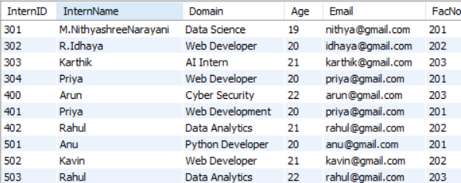

PROGRAM 2:
DELIMITER //

CREATE PROCEDURE GetInternLevel(
IN p_InternID INT,
OUT p_InternLevel VARCHAR(20)
)
BEGIN
DECLARE intern_age INT;

SELECT Age
INTO intern_age
FROM INTERN
WHERE InternID = p_InternID;

IF intern_age <= 20 THEN
SET p_InternLevel = 'JUNIOR';

ELSEIF intern_age <= 22 THEN
SET p_InternLevel = 'INTERMEDIATE';

ELSE
SET p_InternLevel = 'SENIOR';
END IF;
END //

DELIMITER ;

CALL GetInternLevel(301, @level);

SELECT @level AS Intern_Level;

CALL GetInternLevel(303, @level);

SELECT @level AS Intern_Level;
OUTPUT:
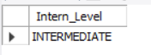

RESULT:
Thus, the stored procedures were successfully created and executed using the INTERN table, and the required intern records and intern levels were obtained successfully.

